1. INTRODUCTION
1.1 Project Overview
Heart Disease Analysis using Tableau
Heart disease is one of the leading causes of mortality worldwide. Healthcare organizations collect large amounts of patient data that can be analysed to identify disease patterns, risk factors, and patient health trends. However, interpreting large datasets manually is difficult and time-consuming.
The objective of this project is to develop an interactive Tableau dashboard that analyzes the Heart Disease 2020 dataset. The dashboard presents key insights using visualizations such as bar charts, pie charts, and filters, allowing users to explore relationships between age, gender, BMI, smoking habits, diabetes, physical activity, and heart disease. The dashboard enables healthcare professionals and researchers to make data-driven decisions through clear and interactive visualizations.

1.2 Purpose
The purpose of this project is to transform raw healthcare data into meaningful visual insights using Tableau. The dashboard helps users understand the major factors contributing to heart disease, compare different patient groups, and identify trends in the data. The project also demonstrates the practical application of Business Intelligence and Data Analytics techniques for healthcare analysis.

2. IDEATION PHASE
2.1 Problem Statement
Heart disease remains one of the most common health problems across the world. Although healthcare organizations collect extensive patient information, extracting useful insights from large datasets is challenging without visualization tools.
The problem addressed in this project is to analyse healthcare data and identify the major risk factors associated with heart disease using Tableau. The interactive dashboard helps users easily understand patterns and relationships in the data.

2.2 Empathy Map Canvas
Users
- Healthcare Professionals
- Doctors
- Medical Researchers
- Hospital Management
- Public Health Organizations
Think
- Which age group has the highest heart disease risk?
- How does smoking affect heart disease?
- Does diabetes increase heart disease occurrence?
- Which lifestyle factors contribute most to heart disease?
Feel
- Need accurate and easy-to-understand reports.
- Want quick access to patient insights.
- Require better decision-making support.
Say
- "We need interactive healthcare dashboards."
- "Patient trends should be easy to analyse."
- "Healthcare decisions should be supported by data."
Do
- Analyse patient information.
- Compare health conditions.
- Monitor disease trends.
- Generate healthcare reports.
Pain Points
- Large healthcare datasets are difficult to analyse manually.
- Reports are time-consuming to prepare.
- Important trends may be overlooked.
Gain
- Faster decision-making.
- Better understanding of health risks.
- Improved patient care.
- Interactive visual reports.

2.3 Brainstorming
Several ideas were considered during project planning, including healthcare data analysis, patient monitoring, disease prediction, and hospital management dashboards. Heart Disease Analysis was selected because it addresses an important healthcare challenge and demonstrates the effectiveness of Tableau in transforming raw data into meaningful visual insights. Interactive dashboards were designed to allow users to explore health indicators and identify major risk factors associated with heart disease.

3. REQUIREMENT ANALYSIS
3.1 Customer Journey Map

Stage | User Activity | User Goal | System Response
Data Collection | Collect heart disease dataset | Obtain patient data | Dataset is imported into Tableau
Data Preparation | Clean and verify data | Ensure accurate analysis | Data is organized into dimensions and measures
Dashboard Creation | Build visualizations | Display healthcare insights | Interactive charts and graphs are created
Data Analysis | Explore dashboard | Identify disease patterns | Filters and visualizations provide insights
Decision Making | Review results | Make informed healthcare decisions | Dashboard supports data-driven decisions

3.2 Solution Requirement
Functional Requirements
- Import healthcare dataset into Tableau.
- Perform data cleaning and preparation.
- Create worksheets for different analyses.
- Develop an interactive dashboard.
- Apply filters for Age, Gender, Smoking, Diabetes, and General Health.
- Display charts and graphs dynamically.
- Present insights using Tableau Story.
Non-Functional Requirements
- User-friendly interface.
- Fast dashboard response.
- Accurate data visualization.
- Easy navigation.
- Reliable performance.
- Easy maintenance and updates.

3.3 Data Flow Diagram
Level 0 DFD
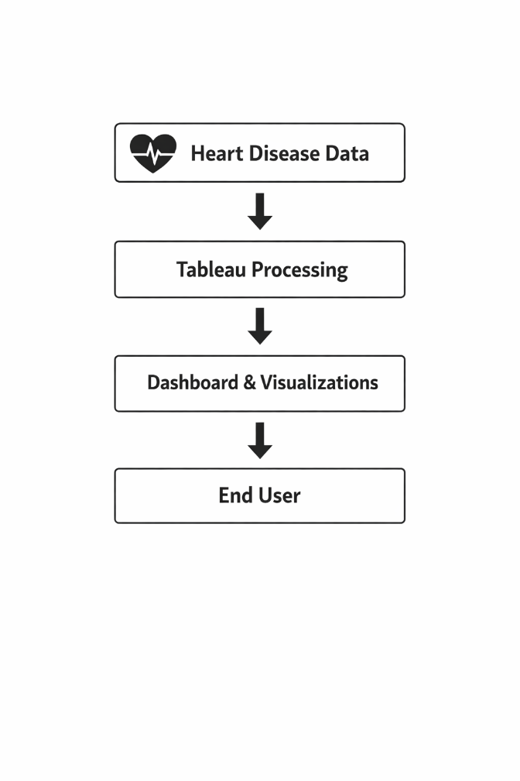
3.4 Technology Stack
Technology | Purpose
Tableau Desktop | Dashboard Development
CSV Dataset | Data Source
Microsoft Excel | Data Cleaning
Windows 10/11 | Operating System
Business Intelligence | Data Visualization

4. PROJECT DESIGN
4.1 Problem Solution Fit
The project addresses the challenge of understanding large healthcare datasets by transforming raw patient information into interactive visualizations. Tableau dashboards help users analyse heart disease patterns efficiently through filters, charts, and summaries, making it easier to identify high-risk groups and support informed healthcare decisions.

4.2 Proposed Solution
The proposed solution is an interactive Tableau dashboard that:
- Imports the Heart Disease dataset.
- Cleans and prepares healthcare data.
- Creates multiple worksheets.
- Combines worksheets into an interactive dashboard.
- Allows filtering by age, gender, smoking, diabetes, and health status.
- Displays meaningful insights through visualizations.

4.3 Solution Architecture

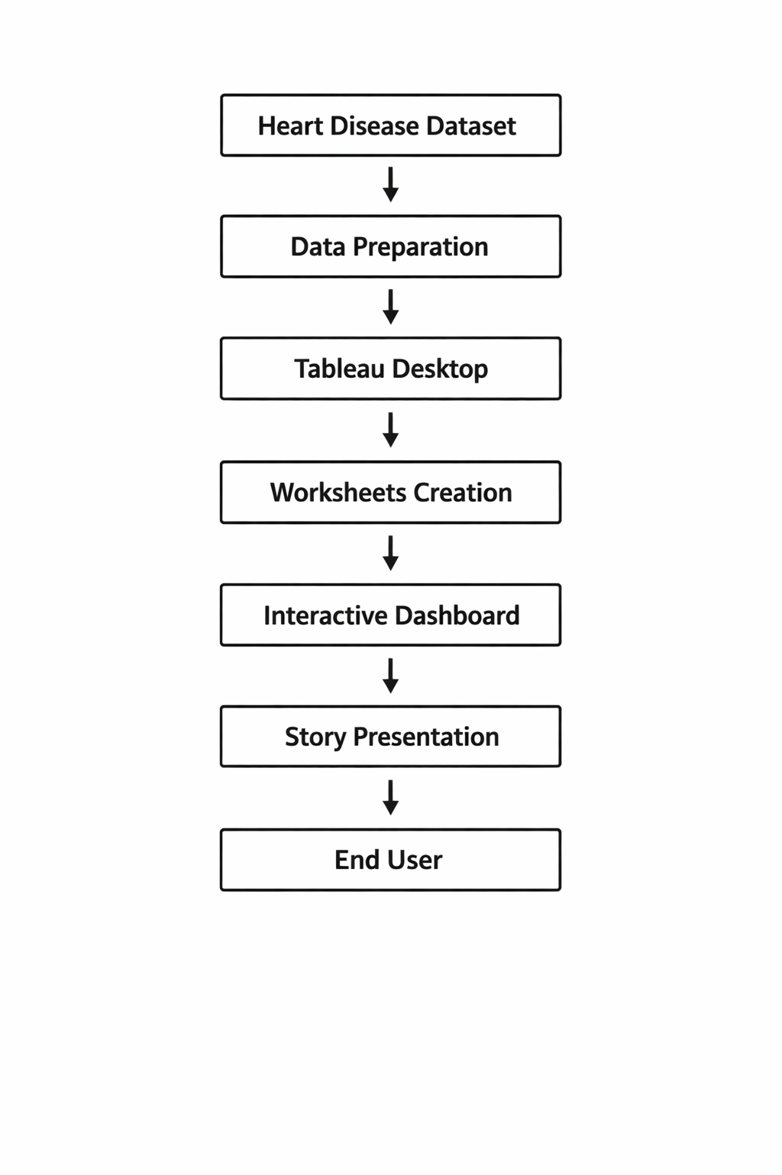

5. PROJECT PLANNING & SCHEDULING
5.1 Project Planning

Phase | Activity
Week 1 | Project Selection
Week 2 | Dataset Collection
Week 3 | Data Cleaning
Week 4 | Tableau Dashboard Design
Week 5 | Worksheet Development
Week 6 | Dashboard Creation
Week 7 | Story Creation
Week 8 | Testing and Documentation

6. FUNCTIONAL AND PERFORMANCE TESTING
6.1 Performance Testing
Test Case | Expected Result | Status
Dataset Import | Dataset loads successfully | Pass
Worksheet Creation | Charts displayed correctly | Pass
Filters | Dashboard updates dynamically | Pass
Dashboard Loading | Dashboard opens successfully | Pass
Story Navigation | Story points work properly | Pass
User Interaction | Charts respond to filters | Pass

7. RESULTS
The project successfully analyses healthcare data using Tableau. The dashboard provides meaningful visualizations that help users identify major risk factors associated with heart disease.
Key observations include:
- Older age groups have a higher incidence of heart disease.
- Smoking is associated with increased heart disease risk.
- Diabetes patients are more likely to experience heart disease.
- Poor general health correlates with a greater likelihood of heart disease.
- Regular physical activity is associated with a lower risk of heart disease.

7.1 Output Screenshots
Insert the following screenshots from your Tableau workbook:
- Screenshot of Dataset
- Tableau Data Source
- Worksheet 1 – Heart Disease Distribution
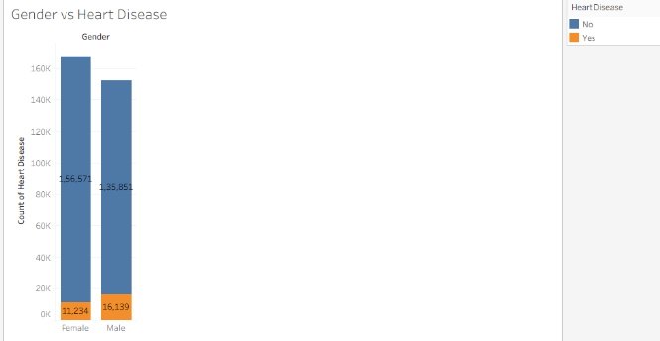
- Worksheet 2 – Age Analysis
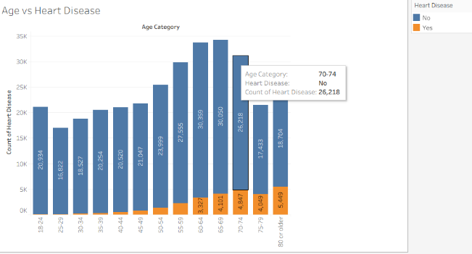
- Worksheet 3 – Gender Analysis

- Worksheet 4 – Smoking Analysis
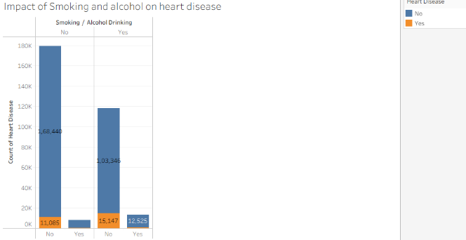
- Worksheet 5 – BMI Analysis
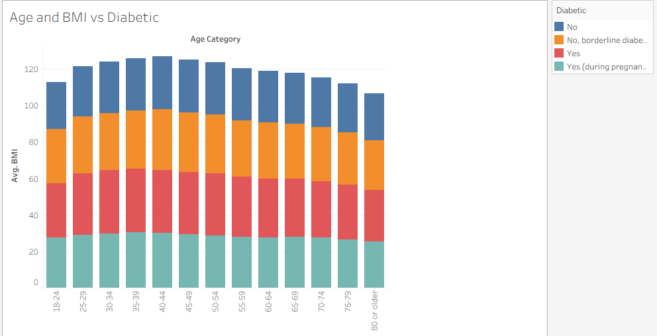
- Worksheet 6 – Diabetes Analysis
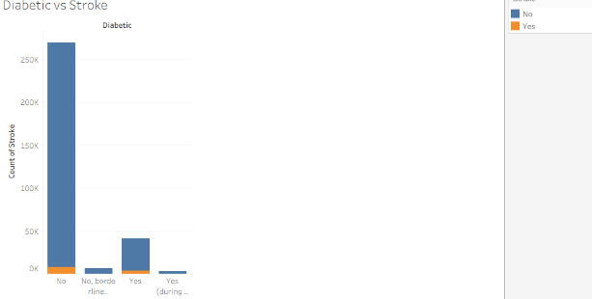
- Final Dashboard
- Story Page

8. ADVANTAGES & DISADVANTAGES
Advantages
- Interactive dashboard.
- Easy-to-understand visualizations.
- Supports healthcare decision-making.
- Fast data exploration.
- User-friendly interface.
- Dynamic filtering and analysis.
- Improves understanding of healthcare trends.
Disadvantages
- Uses historical data only.
- No real-time data integration.
- Predictive analytics are not included.
- Accuracy depends on dataset quality.

9. CONCLUSION
The Heart Disease Analysis using Tableau project successfully demonstrates how Business Intelligence tools can convert raw healthcare data into meaningful visual insights. The dashboard enables users to analyse patient information based on age, gender, smoking habits, diabetes, BMI, and other health indicators. Interactive visualizations improve understanding of disease patterns and support informed healthcare decisions. This project enhanced practical skills in Tableau, data visualization, dashboard development, and healthcare analytics.

10. FUTURE SCOPE
The project can be enhanced by:
- Integrating real-time healthcare datasets.
- Implementing machine learning models for heart disease prediction.
- Publishing dashboards on Tableau Server or Tableau Public.
- Adding geographical analysis using maps.
- Developing mobile-friendly dashboards.
- Including AI-powered healthcare recommendations.
- Connecting the dashboard to cloud databases for live updates.

11. APPENDIX
This project was developed using Tableau Desktop and therefore does not require traditional programming source code. The project consists of Tableau worksheets, dashboards, stories, and calculated fields stored in the Tableau workbook (.twb/.twbx).

Dataset Link
Heart Disease 2020 Cleaned Dataset
You can include the dataset source you used (for example, the CDC Heart Disease dataset or the Kaggle dataset if that is your source).
LINK: C:\Users\admin\Downloads\heart dataset\2020

GitHub
GitHub Repository: https://github.com/lakshmi3412/Data-Analytics

